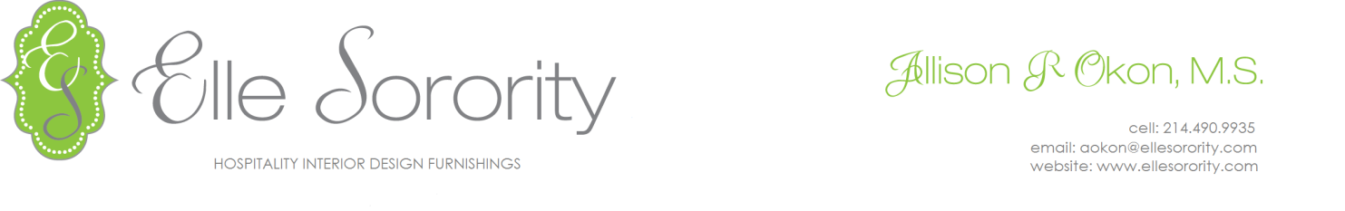
INQUIRY TEMPLATE

- Name of Design Firm & Designer:

- Name of Project:

- Type of Project: (i.e. Refurb)

- Brand: (i.e. Marriott)

- Location:

- * Application/Usage & Quantity needed: (fabric for guest room desk chair & 250 yards of fabric)

- * Budget/Cost: (i.e. Price range under $25 a yard)

- * Timeframe/lead-time (i.e. model room is in January 2018; project deadline end of June 2018)

- Purchaser:

- Other requests/concerns: (i.e. color scheme is blues, teals, and neutrals in guestroom)

- Custom order:

